|  |  |  |  |  |  |  |  |  |  |  |
| --- | --- | --- | --- | --- | --- | --- | --- | --- | --- | --- |
|  | Day | |  | Month | |  | Year | | | |
| **DATE** | **1** | **5** | **–** | **1** | **0** | **–** | **2** | **0** | **2** | **0** |

*All information in this form should be type written.

|  |  |
| --- | --- |
| **Project Title: Tutting Students Through Software** | |
| **Objectives:**   1. Weapon Detection 2. SOP’s Application  * People counting * Face Detection (with or without mask)  1. Web Application interface 2. Mobile Application interface   **Problem Statement:**  Is our Security system reliable enough? Are we relying too much on a single security technology? Why is covid-19 spreading too fast? Can we do anything about it?  **Summary** (300-350 words)**:**  CCTV is one of the feasible functioning/operating requirements that is to be considered in vast safety and security aspects. CCTV cameras are almost installed in every private and public sector such as educational institutes malls, hotels, firms, cinema etc. in order to provide security and measures such as alarms, site design and systems etc. which are not enough for fulfilling today’s need as the increase in number of surveillance camera footages is challenge for CCTV operator to monitor, analyze and make a decision about whether a dangerous situation is about to happen or not. Monitoring multiple screens continuously is quite risky for the single CCTV operator for prolonged time.  So, to overcome this the automated surveillance algorithm is being developed. The main objectives of this is to train CCTV camera for detection of the person and weapon (the most common way to harm/ rob anyone) in the image, , counting people along-with proper mask entrance (most important regarding current situation i.e. Covid-19, as calculated number of people with proper mask application will enter the mall/firm/hotel etc. helping in proper application of SOPs) and alerting the CCTV operator about it through Web application while security guard through android application which were not being provided by primitive CCTV cameras but we will assure you regarding proper provision of above mentioned additional features in our project by integrating algorithm of object detection from field of the computer vision and processing of image through automated surveillance.  **Project Application:**   1. Malls 2. Organizational firms 3. Luxurious houses 4. Institutions 5. Universities 6. Schools/Colleges | **Tools to be used:** |
| Visual Studio  Python  Dream Weaver  CCTV |

**Gantt Chart (for 7th and 8th Semester)**

**Phase 1**

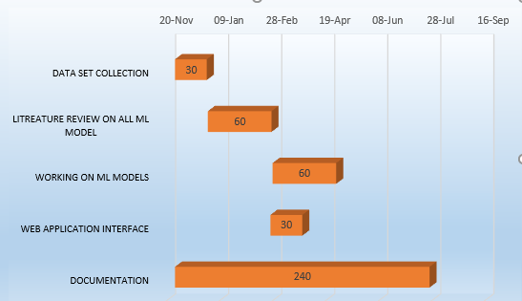

**Phase 2**

**Project Team Members:**

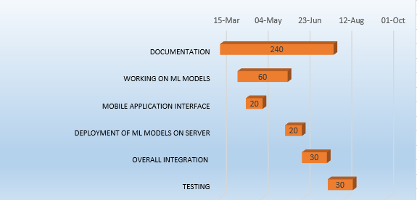

|  |  |  |  |  |  |  |
| --- | --- | --- | --- | --- | --- | --- |
| Sr. # | **CMSID** | **Name in Full**  Use Block Letters | **Department**  **(e.g. BSIT2017F )** | **Email** | **Contact #** | **Signatures** |
| 1 | 41598 | SAHAR BATOOL | BS Information Technology | saharbatool302@gmail.com | 03091184575 |  |
| 2 | 44072 | HUSSNA ALI | BS Information Technology | Hussna.alee25@gmail.com | 03033386439 |  |
| 3 | 41018 | HASNAIN RAZA | BS Information Technology | h.changezi@yahoo.com | 03128039237 |  |
| 4 | 41699 | AFTAB HUSSAIN | BS Information Technology | Ahazara551@gmail.com | 03128248551 |  |

# Advisor’s Consent

I Prof./Dr./Mr./Ms. ________________________________________________ am willing to guide these students in all phases of above-mentioned project / thesis as advisor. I have carefully seen the Title and description of the project / thesis and believe that it is of an appropriate difficulty level for the number of students named above.

**E-Mail Address** (IN CAPITAL LETTERS):______________________________

* **Proposal Accepted**
* **Approved for Initial Presentation**

|  |  |  |
| --- | --- | --- |
| **Note:**  Advisor can’t be changed without prior permission of the Project coordinator. | Signatures and Date  |  | | --- | |  |   **Advisor** |

*To be filled by project approval committee

|  |  |  |  |
| --- | --- | --- | --- |
| **Approval committee member** | **Approved / Rejected/Changes** | **Remarks/ Changes** | **Signatures** |
|  |  |  |  |
|  |  |  |  |
|  |  |  |  |
|  |  |  |  |
|  |  |  |  |

|  |  |
| --- | --- |
| Remarks: | ____________________  **Final Year Project Coordinator** |